**Bubble Chart**

## Simple Bubble Chart

Using the Sample-superstore let's plan to find the size of profits for different ship mode. To achieve this objective we follow the below steps.

* **Step -1** Drag and drop the measure **profit** in to the size shelf under Marks card.
* **Step-2** Drag and drop the dimension **ship mode** to the labels shelf under Marks card.
* **Step-3** Pull the dimension **ship mode** to the colors Shelf under Marks card.

The below chart appears.

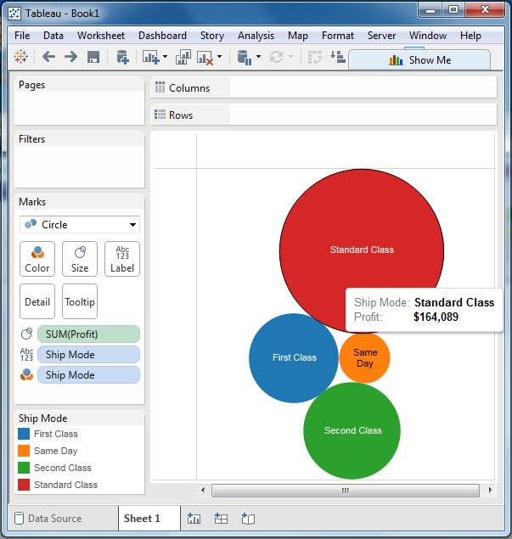

## Bubble Chart with Measure Values

We can also show the values of the measure filed which decides the size of the circles. To do this we drag the sales measure into the Labels shelf. The below chart appears.

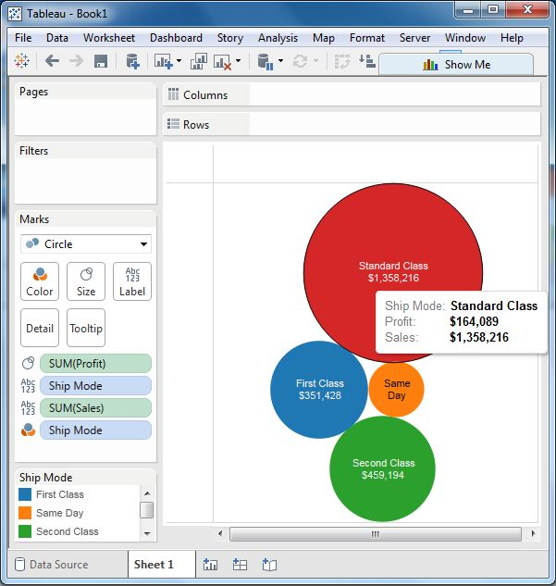

## Bubble Chart with Measure Colors

Instead of coloring each circle with a different colour, we can use a single colour with different shades. For this we drag the measure sales into the color shelf. The higher values represent darker shades while the smaller values represent lighter shades.

